**#Python program for file handling**

fo=open(r"C:\Python\student.txt","wt")

print("Name of the file:",fo.name)

print("Closed or not:",fo.closed)

print("Opening mode:",fo.mode)

fo.close()

print("Closed or not:",fo.closed)

**Output**

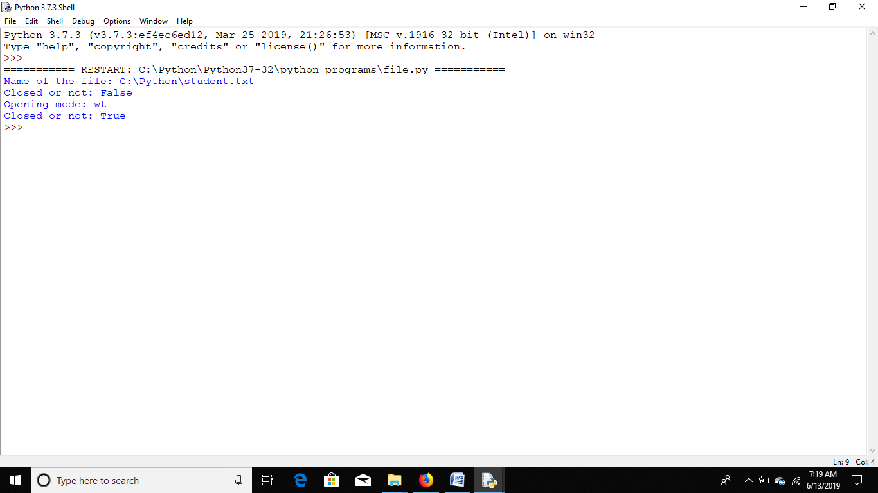

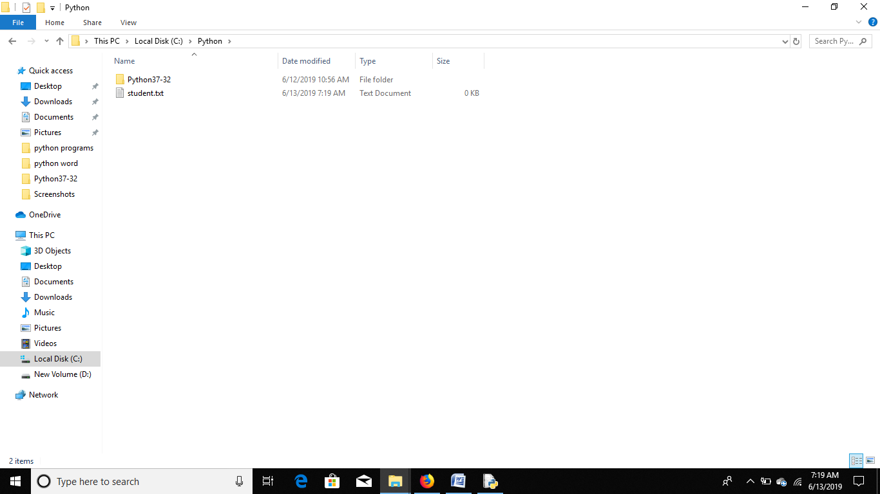

2.

fo=open(r"C:\Python\student1.txt","w")

str1=input("Enter text:")

fo.write(str1)

#x=fo.write(str1)

#print("No. of bytes written:",x)

fo.write("\n We are using file handling")

fo.close()

print("Work Done")

**Output**

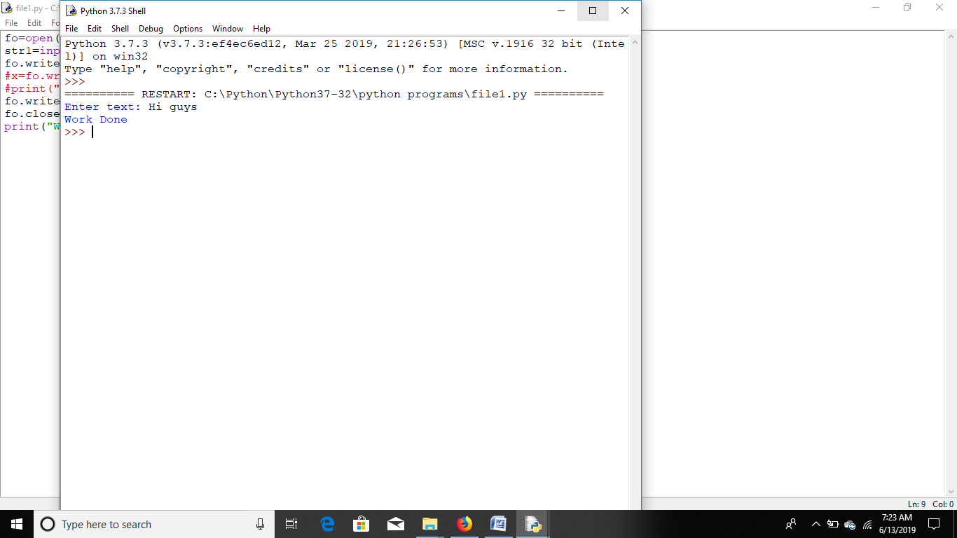

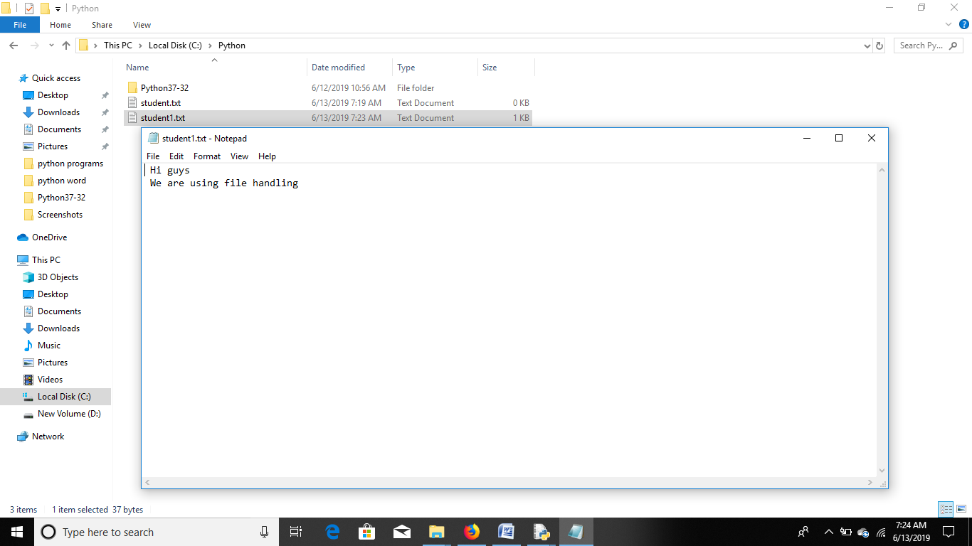

3.

fo=open(r"C:\Python\student.txt","a")

while True:

str1=input("Enter text:")

fo.write(str1+'\n')

#fo.write(r'\n")

choice=input("to exit type x :")

if choice=='x' or choice=='X':

break

else:

continue

fo.close()

print("Work Done")

**Output**

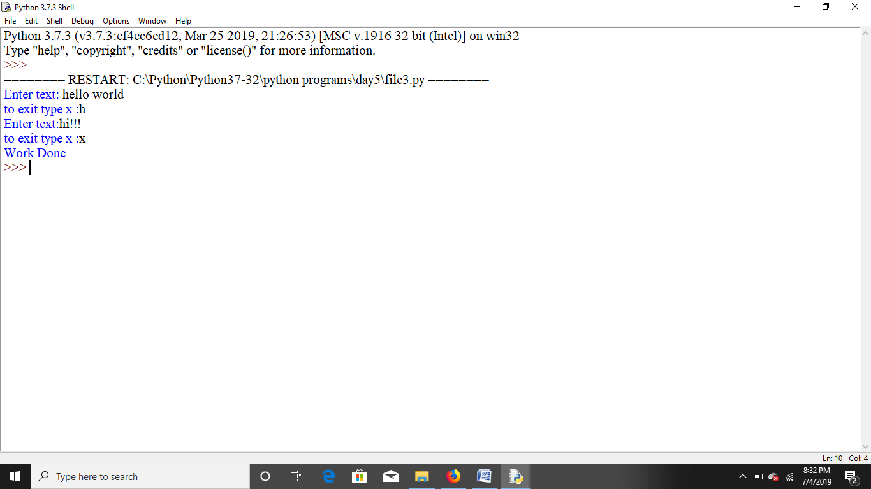

4.

fo=open(r"C:\Python\student.txt","r")

str1=fo.read()

fo.close()

fo1=open(r"C:\Python\student1.txt","w")

fo1.write(str1)

fo1.close()

print("Work done")

**Output**

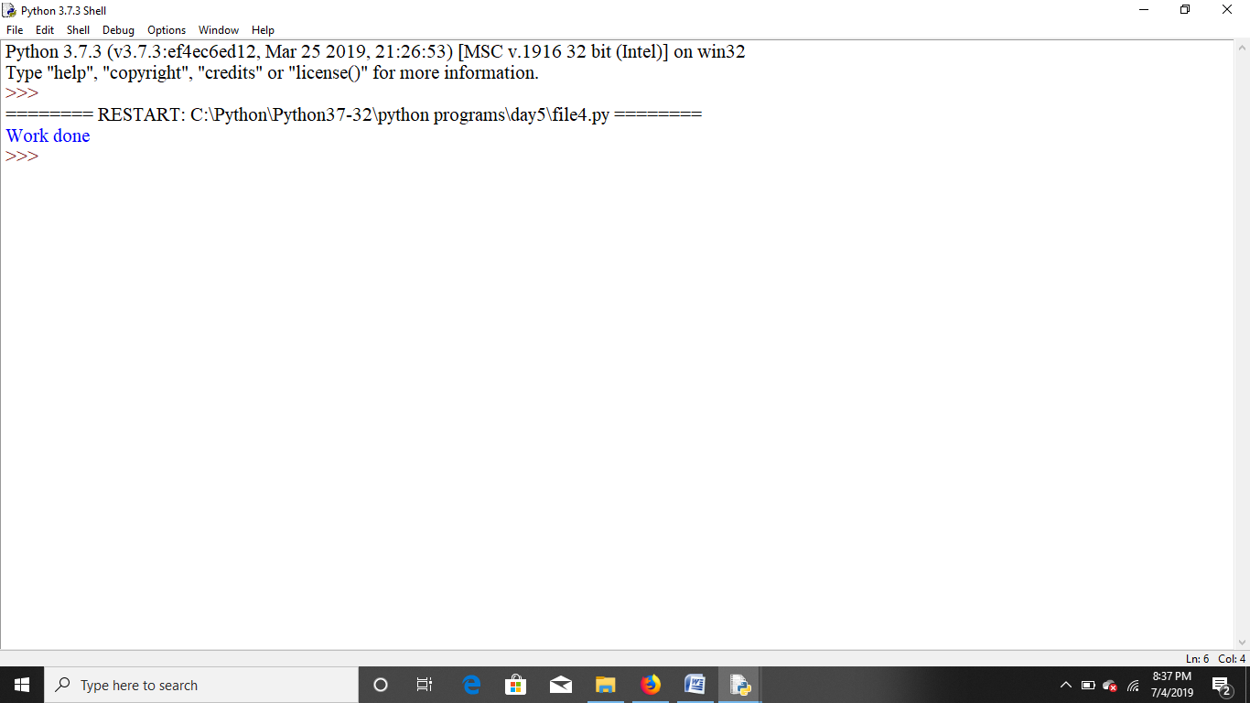

5. filename=r"data.txt"

for line in open(filename):

str1=line

print("string is:",str1)

words=str1[:-1].split("|")

print(words)

if words[-1][-1]=='\n':

words[-1]=words[-1][:-1]

print(words)

print('-'*30)

#print(str1)

**Output**

